RESUME ANALYZER -TEST DEMO
PROBLEM STATEMENT : As a student stepping into the job market, I personally felt this frustration. You spend hours crafting a resume but have no way to know if it actually matches what the company is looking for.
That's why I built the Resume Analyzer & Job Matcher — a Python tool that reads your resume, understands what skills you have, compares them against a job description, and gives you an honest match score with clear suggestions on what's missing.
No guessing. No waiting for rejection emails. Just instant, actionable feedback so you can improve your resume before you even hit send.

Test Case 1 — Sample Resume

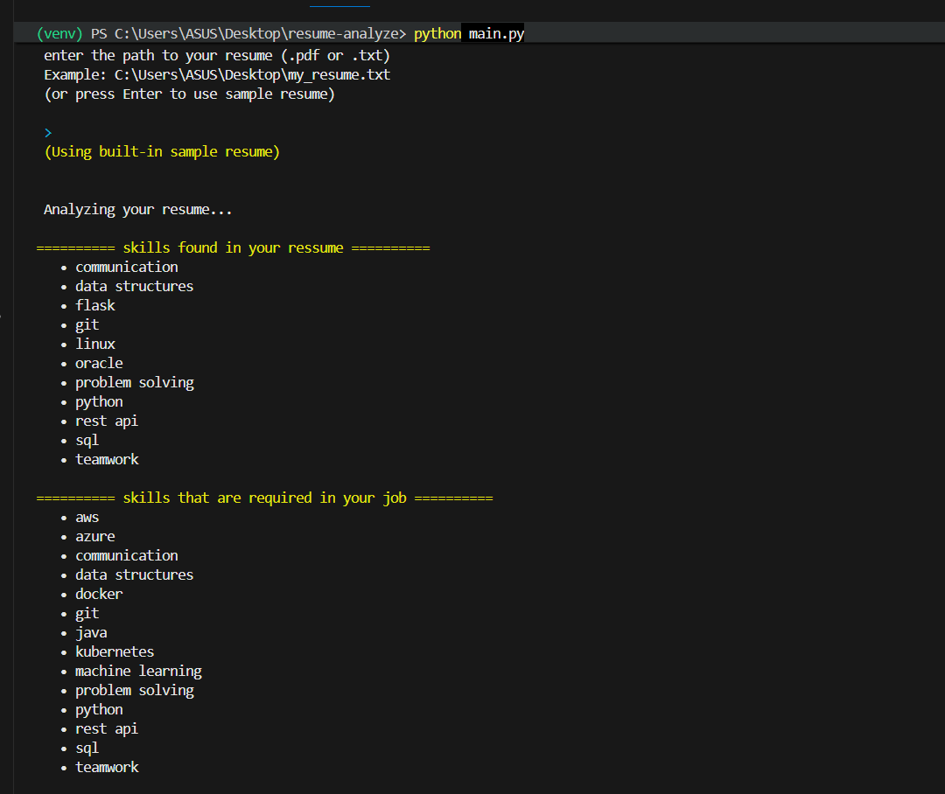
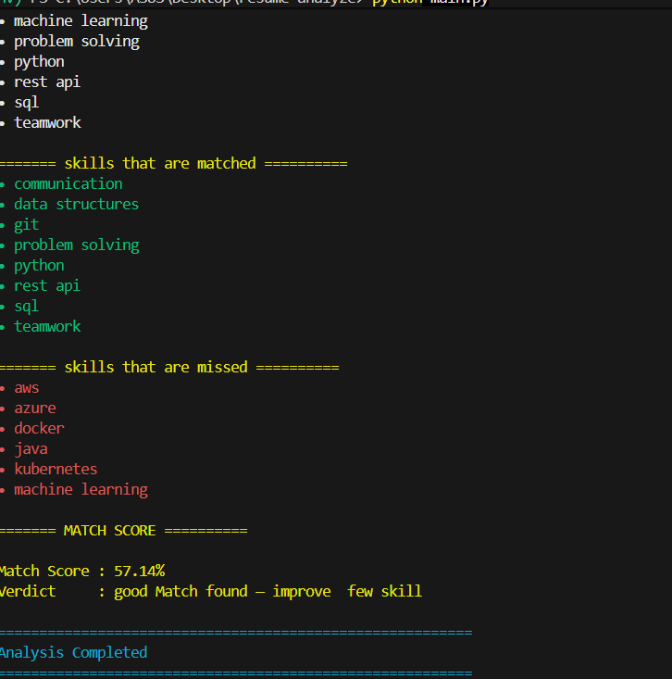

Test Case 2 — High Match Resume
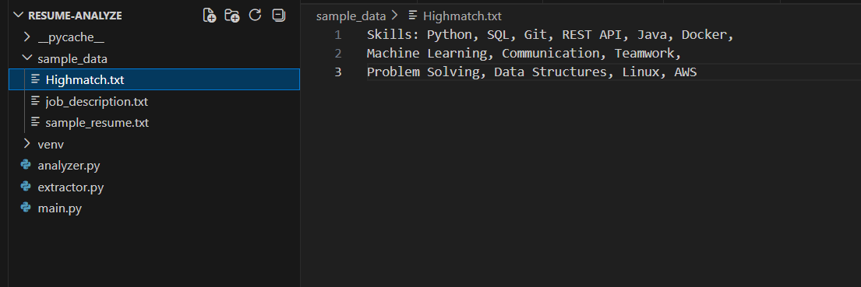
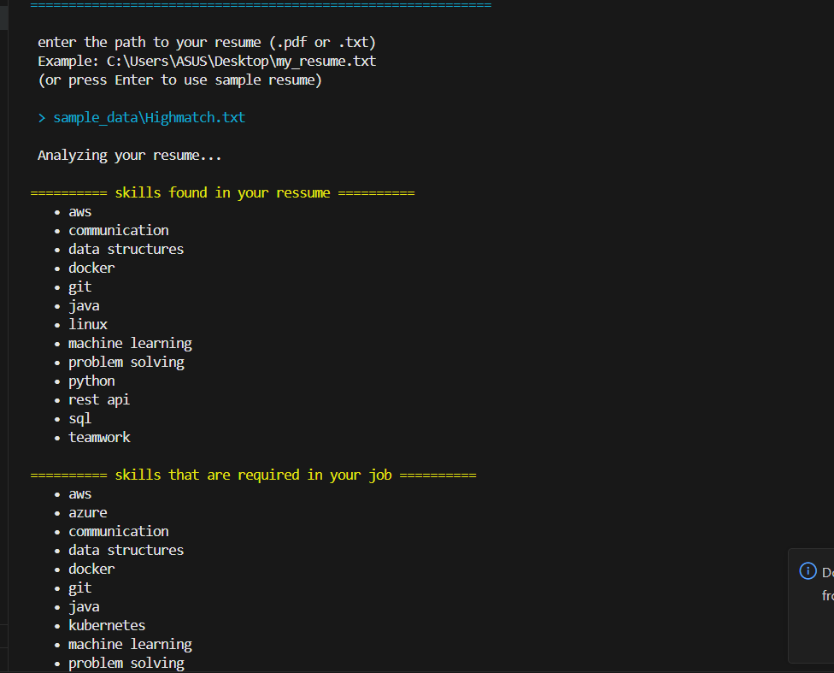
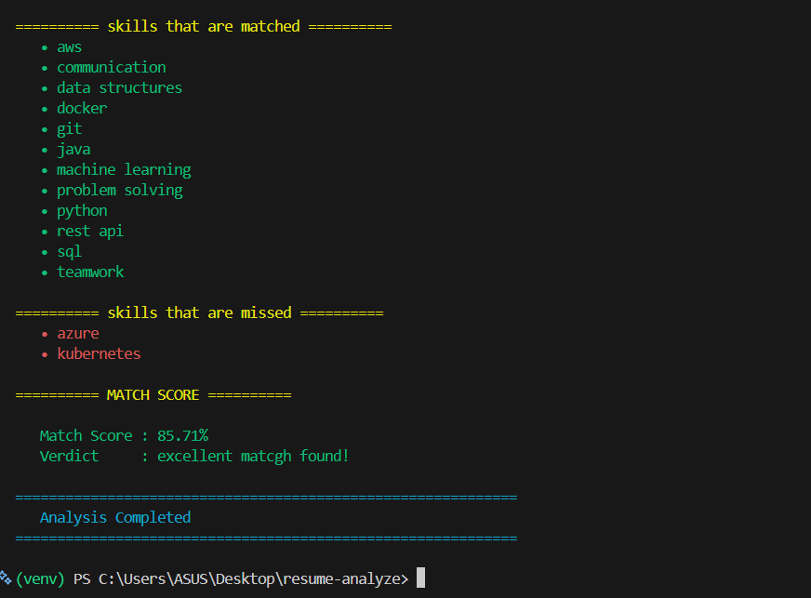

TEST CASE 3- UPLOADING PDF
